### Streusel Apple Pie

#### For the Streusel Topping:

* 1⁄3 cup cup granulated sugar
* 1/4 cup firmly packed light or dark brown sugar
* 1/2 cup plus 2 tablespoons all-purpose flour
* 1 teaspoon ground cinnamon
* 1⁄2 teaspoon ground ginger
* 1/2 teaspoon kosher or coarse salt
* 8 tablespoons (1 stick) cold unsalted butter, cut into small pieces

#### For the Pie Filling:

* 6 large Granny Smith apples, or a mixture of Granny Smith and any other firm baking apple, peeled, cored, and sliced about 1⁄2-inch thick
* 1 unbaked 9-inch deep-dish pie shell
* 1 cup granulated sugar
* 3 tablespoons all-purpose flour
* 1/2 teaspoon ground cinnamon
* 1/4 teaspoon ground cloves
* 1 large egg
* 1 cup heavy (whipping) cream
* 1 teaspoon pure vanilla extract
* [**whipped cream**](https://themom100.com/recipe/make-perfect-whipped-cream/) or vanilla ice cream (optional, but well worth it), for serving

**1.** Preheat [**the oven**](http://amzn.to/1Lj69Lr) to 350°F.

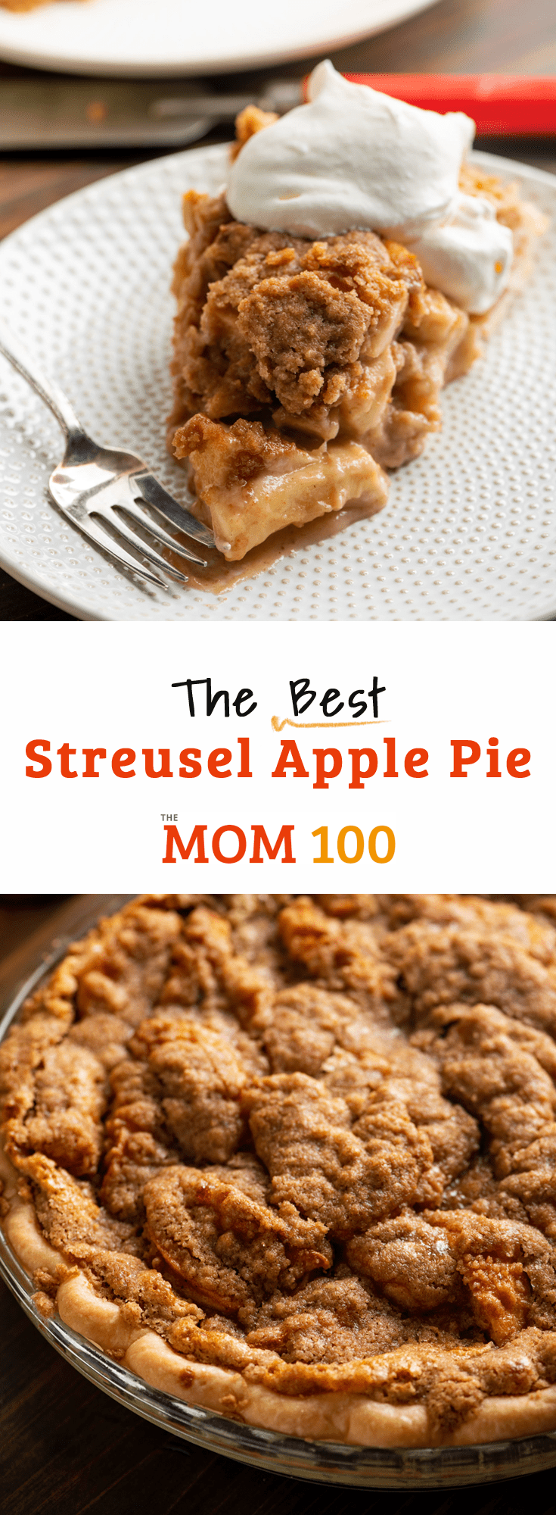

**2.** Make the streusel topping: Combine the 1⁄3 cup of granulated sugar, the brown sugar, 1⁄2 cup plus 2 tablespoons of flour, 1 teaspoon of cinnamon, the ginger, and salt in a [**food processor**](http://amzn.to/1Lj6aPu) and give it a good whirl. Add the pieces of butter and pulse until the butter is incorporated and the mixture is crumbly. Do not overprocess; you don’t want a paste (see Cooking Tip #1). Set the streusel topping aside.



**3.** Make the pie: Put the apples in the pie shell.



**4.** Combine the 1 cup of granulated sugar and the 3 tablespoons of flour, the 1⁄2 teaspoon of cinnamon, and the cloves in a small bowl.



**5.** Beat the egg in a [**large bowl**](http://amzn.to/1Lj6jT3), then add the cream and vanilla and blend well. Add the sugar mixture to the egg mixture and stir to blend. Pour the custard mixture over the apples; if the mixture comes more than three quarters of the way up the side of the crust, stop pouring so it won’t bubble up and overflow.



**6.** Place the pie on a [**baking sheet**](http://amzn.to/1Lj6o9m) in the oven (see Cooking Tip #2) and bake it for 20 minutes. Carefully remove the pie from the oven, making sure the custard mixture doesn’t pour over the side. Evenly and carefully (take your time) distribute the streusel topping over the top of the pie. Carefully (again) return it to the oven and bake until the top is browned and a knife inserted into the pie ensures that the apples are cooked through, about 50 minutes longer.



**7.** Let the pie cool on a wire rack for at least 20 to 30 minutes, then serve it warm with whipped cream or vanilla ice cream, if desired (and who wouldn’t desire that?).